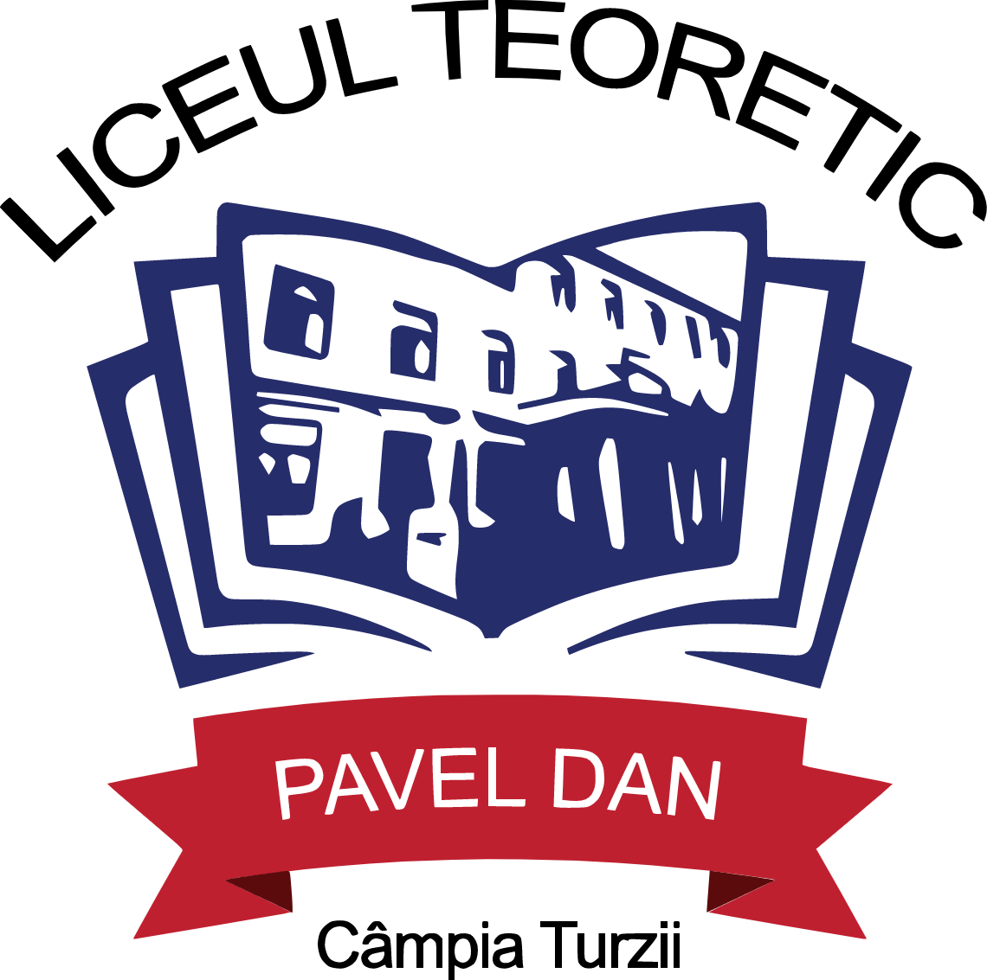


Inspectoratul Școlar Județean Cluj

MINISTERUL EDUCAȚIEI
Liceul Teoretic Pavel Dan”
Str. 1 Decembrie 1918, nr 17, Câmpia Turzii
Tel/fax: 0264368855, tel: 0264368036
email: pavel.dan.ct@gmail.com
www.liceulpaveldan.ro

PROJECT MEETING AGENDA

Organized by the Project Coordinator- Liceul Teoretic “Pavel Dan”, Campia Turzii, Cluj County, Romania as part of Erasmus+ KA220 project “EMPathy- European Melting Pot”, no. 2021-1-RO01-KA220-SCH-000032814, between the 3rd and 5th of May 2022.

Time | Tuesday 3rd of May 2022 |  | Wednesday 4th of May 2022 |  | Thursday 5th of May 2022
8.00 | Breakfast at the hotel | 8.00 | Breakfast at the hotel | 8.00 | Breakfast at the hotel
9.00 | School visit- a tour of Pavel Dan High School- meeting the project team | 9.00 | Project meeting  -Choosing the project logo  -Project communication and visibility- plans and means of doing it | 9.00 | -Risk management analysis- workshop based on brainstorming for possible types of risks and solutions
10.00 | Schools presentations | 10.00 | -Establishing partners’ responsabilities and deadlines for further activities | 10.00 | Handing in Participation Certificates  Applying satisfaction questionnaires
11.30 | Project meeting  -handing in Originally signed mandates and Partnership Agreements  -Risk management analysis | 11.30 | -Project final products and results  -Selection of participants  -Project mid term and final reports | 10.30 | Trip to Cluj Napoca city  Visits to main touristic objectives: Botanical Garden, Citadel Park, the Village Museum and other representative historical monuments to be included in project future activities
12.00 | Project meeting  -Replanning the activities – agreeing on the dates of the following local and transnational project activities  -Gannt Diagram and Activities Calendar | 13.00 | -Visiting students’ spring related exhibition  -Attending a cultural show presented by the Romanian students (spring customs and traditions) | 14.00 | Lunch in Cluj Napoca
13.30 | Lunch at the hotel- (the menu for the day is to be chosen at breakfast time in order to be ready in due time) | 14.30 | Lunch at the hotel (the menu is to be established at breakfast) | 15.00 | Visits to representative churches and historical/ traditional locations in Cluj
15.00 | Visit at Turda Salt Mine –one of the most impressive touristic attractions in our region and in the whole world, carved in salt, hundreds of years ago- a place closely related to some of our project activities and final results as it is part of our history and connected to many ancient traditions. | 15.30- 18.00 | Trip to Rimetea village- suggested to be included in the Unesco patrimony  -Historical and traditional visits to the Unitarian, Reformat and Catholic Churches in Colțești, the ruins of Colțești Citadel and some famous mountainous picks in the region and Savu traditional Romanian wine cellar in Cimbrud (which are to be included in project future activities) | 19.00 | Dinner back at the hotel
18.00 | Romanian Traditional Dinner at Millexim restaurant | 18.00 | -Traditional Dinner at ”Conacul Secuiesc” Colțești (20 euros/ person)

School Principal Project Coordinator
Daniela Cristina POPA Daniela Ioana GIURGIU

